**A**bout **O**ur **P**roject

First Innings Score Predictor for ***Indian Premier League (IPL)***

***A Machine Learning Web App, Built with Flask, Deployed using Heroku***

***In today’s blog, we will build an****IPL Score Prediction model using Ridge Regression****which is just an upgraded form of Linear Regression. We have the IPL data from 2008 to 2017.***

*We will also be building a beautiful-looking GUI using HTML and CSS****.***

***Libraries we have used.***

import joblib

import numpy as np

import pandas as pd

import seaborn as sns

from datetime import datetime

from sklearn.linear_model import Ridge

from sklearn.preprocessing import StandardScaler

from sklearn.model_selection import RandomizedSearchCV

from sklearn.metrics import r2_score,mean_absolute_error,mean_squared_error

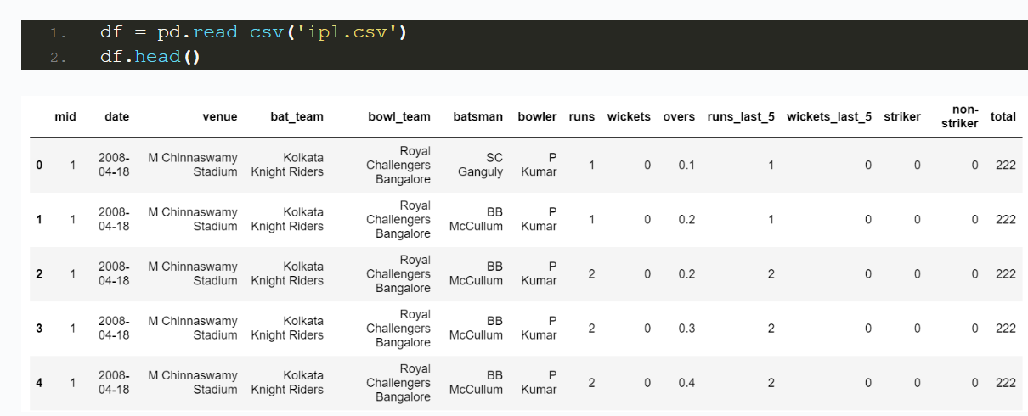

**On the basis of these features it will predict the range of final score.**

